Finger motion mechanism and simulation:

# Introduction: how we chose the mechanism

In order to understand how to build a mechanism that simulates the human hand movement we need to understand how the normal biological hand movement works, for instant a human finger consists of 3 segments that called phalanges these phalanges are proximal phalange, middle phalange, and distal phalange the movement of these segments are controlled by nerves which in our case is represented by the motors where each motor is responsible to control the motion of a whole finger with its 3 segments and should moves like a natural hand moves and since this process is complicated we need to simplify this process as much as we can for example we can consider manufacturing the last tow segment of the finger which are middle and distal phalanges as a single part that will make it easier for us to control the motion as building a mechanism that control the motion of two links is easier than controlling a three links and for the mechanism it self we found that the best mechanism to simulate the finger motion is the **four bar mechanism**  which will be explained in detail in the next topic

# 4-bar mechanism

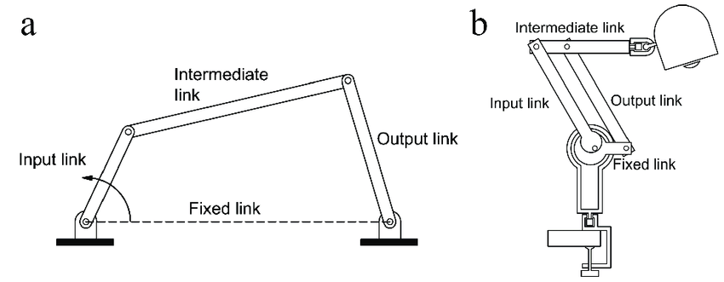A four-bar mechanism is a mechanical linkage consisting of four rigid bars connected by pivot joints. These mechanisms are widely used in engineering and machinery to convert rotary motion into linear motion or vice versa. The four bars are typically referred to as "cranks" and "rocker arms," and they are connected in such a way that they can transmit motion and force effectively.

Here's a basic explanation of how a four-bar mechanism works:

1. **Components:** A four-bar mechanism consists of four bars or links, each of which is connected to the others through pivot joints or hinges. These bars are often labeled as follows:

**- Input Crank (Link 1):** The bar that receives the initial rotary motion.

**- Coupler Link (Link 2):** The bar connected to both the input crank and the output rocker arm.

**- Output Rocker Arm (Link 3):** The bar that is responsible for the final motion or output.

**- Fixed Ground Link (Link 4):** A stationary bar, often used as a base to which other links are attached.

1. **Pivot Joints:** The pivot joints, also known as revolute joints or hinges, allow the bars to rotate relative to each other. These joints are the key to the mechanism's ability to transmit motion.

The design and analysis of four-bar mechanisms involve mathematical principles, including kinematics, dynamics, and geometry, to determine the desired motion and forces at different points within the mechanism. Engineers use software tools and simulations to optimize these mechanisms for specific applications, ensuring they perform their intended functions efficiently and accurately.

# A blue and white drawing of a map Description automatically generated with medium confidenceImplementing the 4-bar mechanism in our design

Fixed link

Input link

Slider (input motion)

coupler

Output link

The four elements of the 4-bar mechanism are presented in the above figure as well as the input motion which is the motion of the guide nut in the power screw mechanism this motion is represented here by the slider as the guide nut moves only in y-direction this motion control the whole mechanism as it transfer the motion on the motor to the mechanism input link.

To imagine how this mechanism is going to work a simulation software program (SAM the ultimate mechanism designer) is used to simulate the motion of the finger and will help us to determine the required input motion we need in the y-axis for the finger to be fully closed.

# Software simulation (SAM)

## What is Sam?

SAM (Simulation and Analysis of Mechanisms) is an interactive PC-software package for the motion and force analysis of arbitrary planar mechanisms, which can be assembled from basic components including beams, sliders, gears, belts, springs, dampers and friction elements.

## How the simulation is built?

- draw Initial design of the finger segments on inventor.

- Export a 2D sketch in the format of DXF of the finger side face marking the point of the joints from inventor.

- Importing these DXF files in SAM software.

- Aligning and joining the finger segments to draw the start and the required end position of the finger.

- Start building the 4-bar mechanism relative to the start position.

- Attach the joints and links of the mechanism with its corresponding segments and joints of the DXF drawings.

- Drawing and attaching a slider that represents the motion of the guide nut to the mechanism.

- Defining the input motion to the mechanism in our case is the slider.

- Define the output data to be presented on a graph in our case (the motion of the slider in y direction, the angel rotated by the proximal phalange)

- Run the simulation.

- Observing the output and changing the slider and fixed nodes position till we reach the optimal position (the least distance travelled by the slider that gives us the largest angle the proximal phalange rotates)

## Sam results

The upcoming figures show the motion of the finger in steps from its upper extreme position to its lower extreme position. We can say that this motion checks the box where the motion of the finger looks natural like a human hand movement.

On the left side of the photo, we will notice a graph that represents the relation between two lines.

**First the purple line:** it represents how long the slider have to move down the y-axis for the finger to be fully closed and it moved down throw the range by a distance nearly equal to 8 mm which is accepted for us as 8 mm is a small distance for the guide nut to move along the power screw as it won’t be necessary to build a long lead screw that might take a large space inside the hand palm thus making the overall dimensions of the hand bigger and inconvenient.

**Second the red line:** the red curve represents the motion of the first segment of the finger (proximal phalange) in degrees which we can see here that the finger rotates by an angle of nearly 90 degree which what a normal human hand proximal phalange will rotate for the hand to be fully closed.

We can also export this relation from the SAM software as a numerical value in the form of a table for better illustration and to ease the design process.

|  |  |  |
| --- | --- | --- |
| Result listing SAM 8.3.4 Mechanism: 4-bar mechanism | | |
|  |  |  |
| ________________________________________________________________________ | | |
| Nr | A(1) | Uy(7) |
| [-] | [deg] | [mm] |
| 0 | 89.5445 | 0 |
| 1 | 80.14272 | -0.66667 |
| 2 | 71.58661 | -1.33333 |
| 3 | 63.6795 | -2 |
| 4 | 56.27637 | -2.66667 |
| 5 | 49.26343 | -3.33333 |
| 6 | 42.5465 | -4 |
| 7 | 36.04357 | -4.66667 |
| 8 | 29.67841 | -5.33333 |
| 9 | 23.37566 | -6 |
| 10 | 17.05356 | -6.66667 |
| 11 | 10.61766 | -7.33333 |
| 12 | 3.9414 | -8 |

## To wrap it all up

Simulation helped us to imagine how the four-bar mechanism will operate and move the finger naturally and helped us to achieve the minimum required distance the guide nut has to move for the finger to be fully closed thus helped us to decrease the overall dimensions of the lead screw that helped us to decrease the overall dimensions of the hand